**CPT-281 Team Project 1-A: Movie Management System**

Contributors: Jordan Pham, Athul Jaishankar

Project Summary:

This project is a Movie Management System that helps in maintaining two lists of movies: movies currently "showing" in the theater and movies "coming" to the theater. The system utilizes doubly-linked lists and iterators for efficient management of movie data.

Technical Requirements:

▪ A movie has the following attributes:

1) release_date (Date type). You probably need to create your own Date class.

2) name (string type).

3) description (string type).

4) receive_date (Date type).

5) status (enum type). This data field tells if a movie is received or released.

▪ Movies in the "showing" list have status of released; movies in the "coming" list have status of received.

▪ The file that keeps track of the movies is a plain text file. An original file input format is made based on this example:

Glass, 01/18/2019, Drama/Fantasy, 01/12/2019, released

Miss Bala, 02/01/2019, Mystery/Thriller, 01/17/2019, received

In the example above, each line stores a movie. The information of the movie is structured like

this: name, release_date, description, receive_date, status.

Functionality:

* Display Movies: Display both "showing" and "coming" movies.
* Add Movie: Add a new movie to the "coming" list, considering various constraints.
* Start Showing Movies: Move movies from "coming" to "showing" list based on a specified release date, considering constraints.
* Edit Movie: Edit a movie in the "coming" list (e.g., update release date or description).
* Order Coming List: Keep the "coming" list ordered by release date.
* Count Coming Movies: Count the number of "coming" movies with a release date earlier than a specified date.
* Menu-based Interface: Implement a menu-based interface for user interaction.
* File I/O: Read movies from an initial file, and write changes back to the file.
* This program uses the C++ built in STL for the list class.

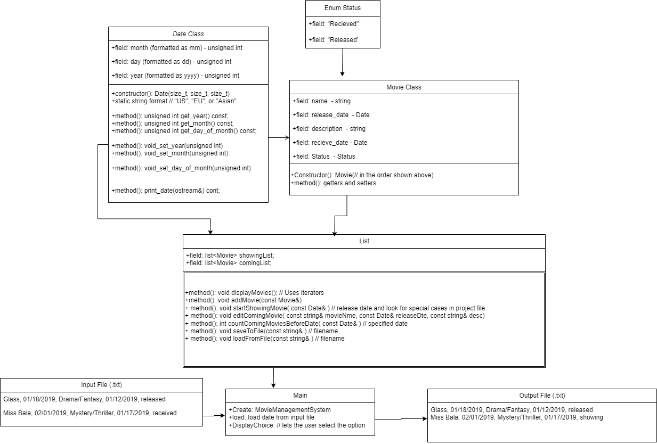

Shown above is the UML diagram for this project

**Test Cases**

Test Case #1:

The first input file is shown below:

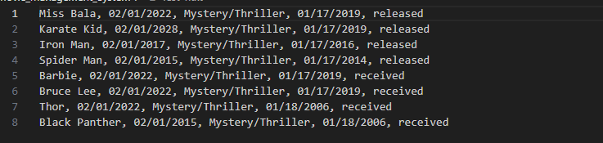

The expected output would be to have movies separated into two categories: “The Showing Movies” and “The Coming Movies.” Movies in “The Showing Movies” are noted as “released” in the movie class and are sorted from earliest release date to latest release date. The movies in “The Coming Movies” are noted as “received” in the movie class and sorted from earliest date received to latest date received.

The output from the first test case is shown below:

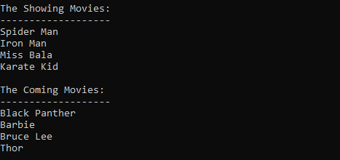

**Contributions:**

Athul: Team leader/”Head Chef”

* Scheduled team meetings
* Designed the project outline divided tasks
* Lead programmer
* Lead bug-fixer

Jordan: Team member/”Mise en place”

* Setup the header files
* Contributed with brainstorming